EL DORADO UNION HIGH SCHOOL DISTRICT
Instructional Trip Request
1. In accordance with BP/AR 6153, was a conference held with the Principal/Designee to discuss the feasibility of the trip BEFORE any arrangements were made? Yes No
2. This request must be submitted to the appropriate school administrator at least 21 CALENDAR DAYS prior to activity.
3. No student in a class or group may be excluded because of lack of funds (EC 35330). No group may go on an outing if any member is excluded because of lack of funds.
4. Trips more than 300 miles, overnight, or out of state or country require 2 MONTHS PRIOR NOTICE and approval by the Board.
5. Upon approval, teacher must execute Form 6153-7, Parent/Guardian Instructional Trip Authorization.

TRIP INFORMATION
^{DATE SUBMITTED} |  | SCHOOL (Check) |  | EDHS IHS ORHS PHS UMHS VA
^{ACTIVITY} |  |  |  |  |  | ^{ACTIVITY LOCATION}
SPONSORING TEACHER(s) / ORGANIZATION |  |  |  |  |  | DATES OF TRIP | DATE | TIME | LOCATION
 |  |  |  |  |  | PICKUP
^{EST. TOTAL TRIP MILES}  Within 300-mile radius of transportation Out of State  Beyond 300-mile radius of transportation Out of Country  Describe trip itinerary on reverse side. |  |  |  |  |  | RETURN
 |  |  |  |  |  | EST. TOTAL HOURS: |  | NO. INSTRUCTIONAL DAYS/HOURS MISSED
CERTIFICATED STAFF |  |  |  |  |  | OTHER SUPERVISING ADULTS |  |  | PHONE
Staff | Classes Covered by
TRANSPORTATION INFORMATION
APPROX. NO. OF STUDENTS (Provide final list of students to Attendance Office and Transportation no later than day before trip.) |  |  |  |  | NO. OF ADULTS SUPERVISING
^{TRANSPORTATION REQUESTED}  (Be specific, specify arrangements being made)  District (See AR 6153, '4.2.2 and 4.3) Commercial  Private (See AR 6153, '4.7) Other: |  |  |  |  | AR 3541.1 and AR 6153 state: Transportation to and from all district-sponsored field trips within a radius of 300 miles of Placerville will be performed by district employees. All other trips may be contracted out; however, Transportation shall be contacted and given an opportunity to submit a quote on all trips.
(REQUIRED) Transportation has been given an
opportunity to submit a quote on this trip. X
Director of Transportation’s Signature Date Estimate No.
TRIP COSTS (THIS SECTION MUST BE COMPLETED REGARDLESS OF FUNDING SOURCE.)
Funding Sources Fund-raising activities (Describe on reverse side) Sponsored organization
Budget allocation Other (Briefly explain):
 |  |  | BUDGET CODE OR FUNDING SOURCE |  |  |  |  |  | VERIFIED BY
Transportation Cost | $
Driver Time | $
Lodging Cost | $
Meal Cost | $
Entry Fees / Registration | $
Personal Costs Per Student:  $ x # of students | $
Substitute | $
TOTAL | $ |  | TOTAL MUST BE CALCULATED BEFORE SUBMITTING FORM.

INSTRUCTIONAL TRIP REQUEST (continued)
EDUCATIONAL OBJECTIVES OF THE TRIP:
ITINERARY (Include number and length of instructional activities, place(s) students will stay, number and grade levels of students participating, other pertinent information):
FUND-RAISING:
OTHER SUPPORT (Include plan (list below or attach) to support students unable to contribute all or part of the personal costs of the field trip):
No. Students | Plan:

ADMINISTRATION USE ONLY / APPROVALS

APPROVALS:
Approved as submitted | Approved with the following condition(s):
Not Approved

Department Chairperson________________________________________________ Department__________________________

Principal (for trips within a 300-mile radius)_____________________________________________________ Date______________________

TRACKING:
DATE | ITEM | COMMENT
 | Transportation called | Contact: Hours Verified
Request for Transportation form submitted
(see Form 3541.1A or 3541.1B)
 | Activity added to Master Contract
 | Sent to District Office for approval
 | Returned to teacher
Final list of students submitted to Attendance
Office and Transportation

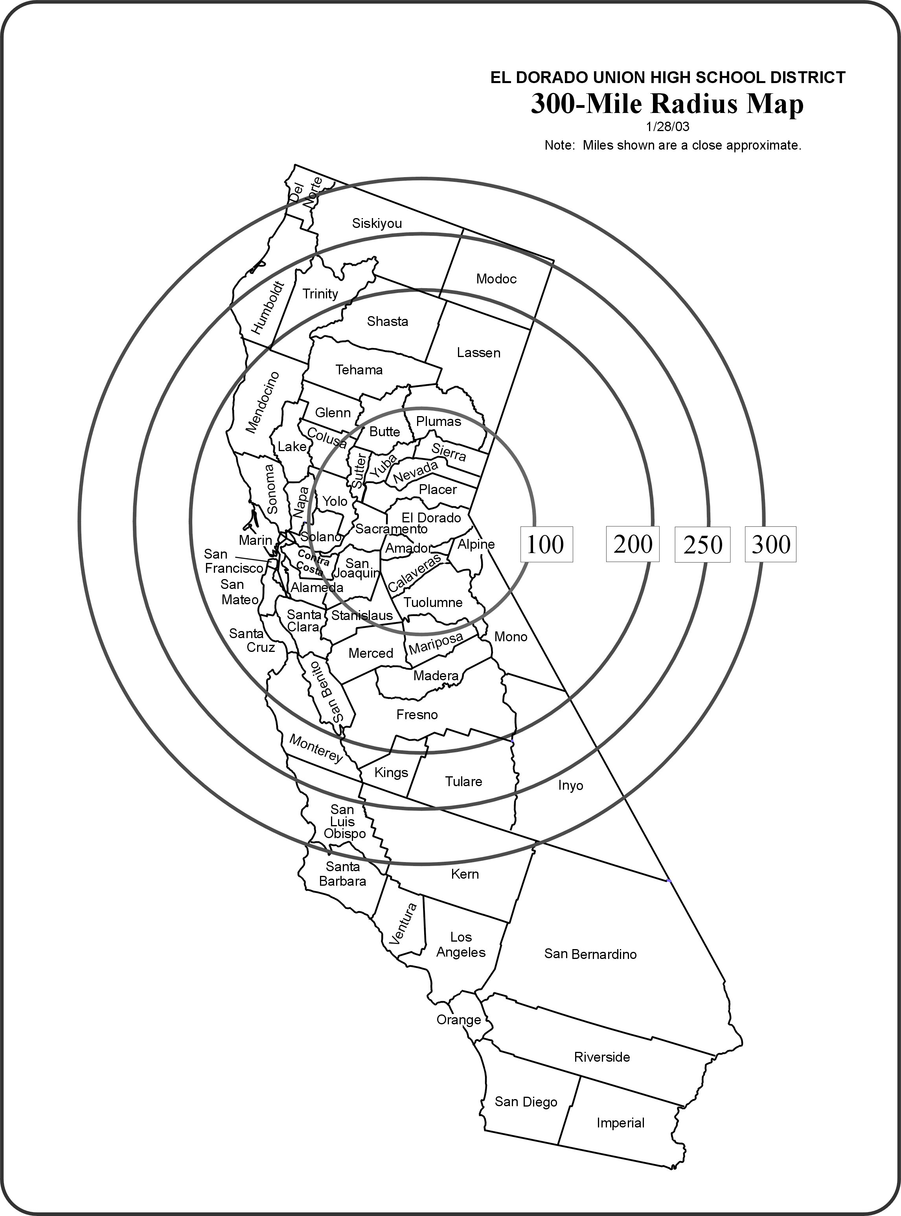
Consult a map or on-line map service to determine a more accurate mileage.
NOTE: Even though trips to Nevada or to the southern portion of Oregon are within 300 miles, they are still out-of-state trips and require Board approval.

